WORK-CASE №2

3,4. Виконав Горохов Данило

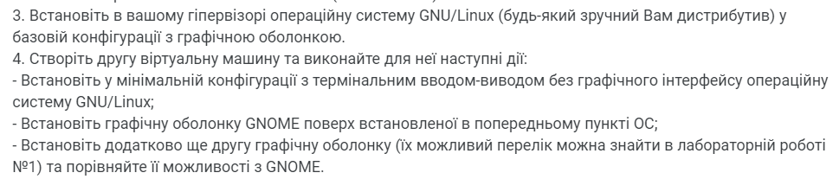

1. For further installation, I used the Ubuntu graphical shell to use the terminal and minimal functions.
2. 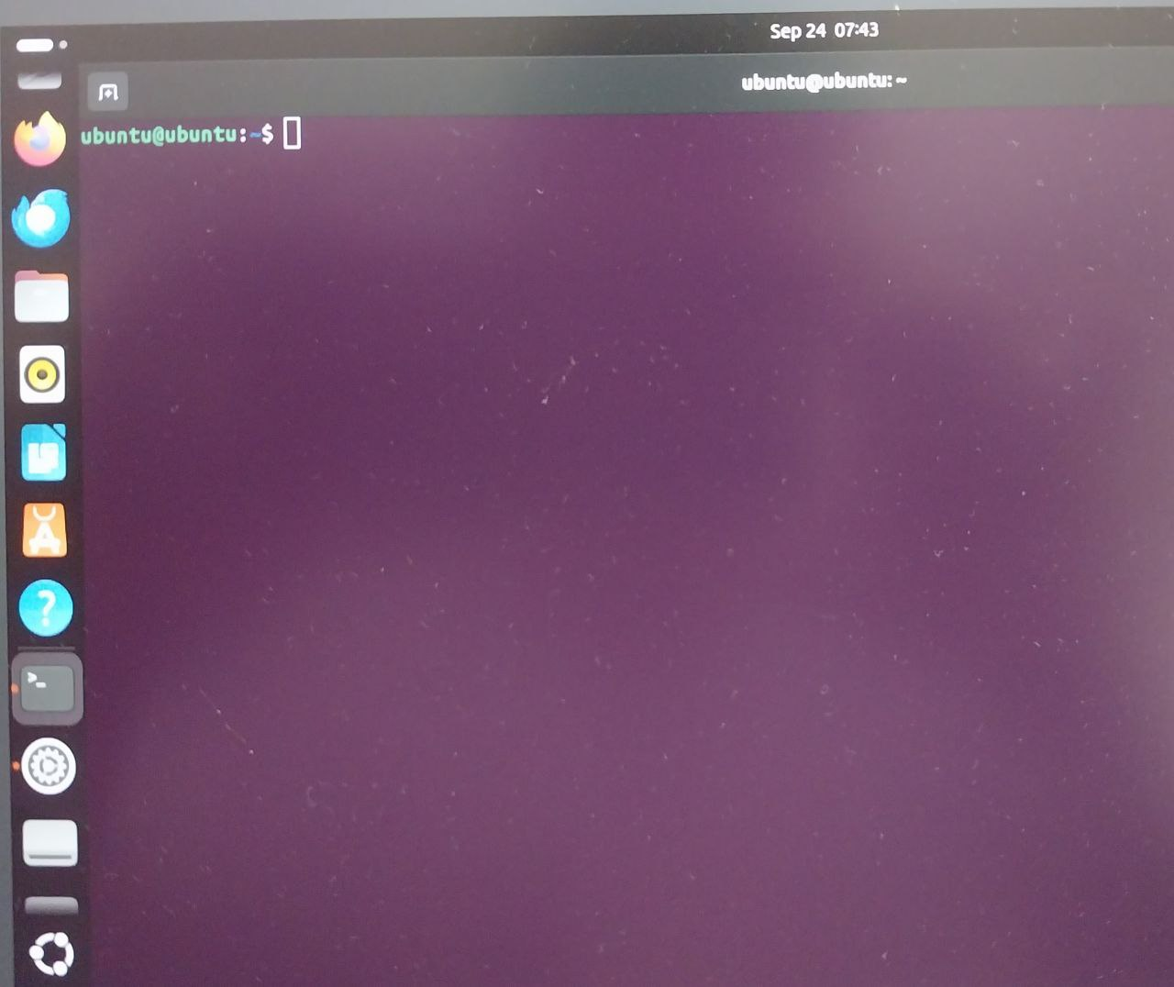Terminal in the Ubuntu graphical shell:
3. 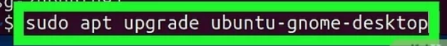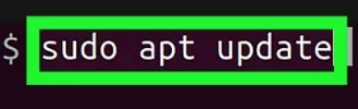Installing GNOME(To download, I used the commands in the terminal):
4. 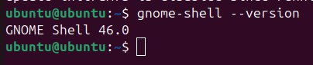As a result:
5. Further in the work, on top of the installed graphical system, you need to install another graphical shell, I chose **sddm.**
6. To install sddm, we need to write several commands:



1. 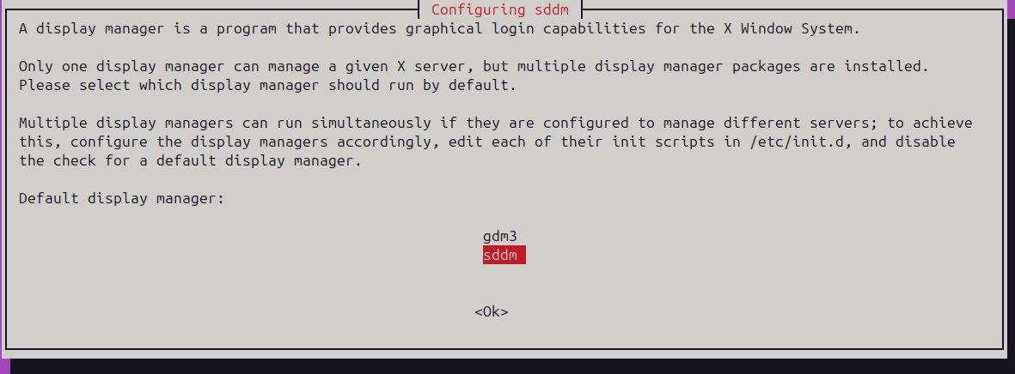As a result(we can choose which graphical shell we can use):

**GNOME** and **SDDM** serve different purposes within the Linux environment, but they are often compared due to their roles in user experience.

**GNOME (Desktop Environment)**

* **Purpose**: GNOME is a full desktop environment providing a graphical user interface (GUI) for interacting with the system.
* **Features**:
  + **Activities Overview**: A unified workspace for managing open windows, virtual desktops, and launching applications.
  + **Customization**: Supports themes, extensions, and layout changes via GNOME Tweaks.
  + **File Manager**: Offers a built-in file manager (Nautilus) for browsing and managing files.
  + **System Settings**: Comprehensive system settings for adjusting appearance, network, power management, and more.
  + **Accessibility**: Features high contrast themes, screen readers, and keyboard accessibility options.

GNOME is suitable for users who want a complete, integrated desktop experience with a focus on simplicity and productivity.

**SDDM (Simple Desktop Display Manager)**

* **Purpose**: SDDM is a **display manager** that handles user logins and session management before entering the desktop environment.
* **Features**:
  + **Login Screen**: Provides a customizable login screen for selecting users and desktop environments.
  + **Lightweight**: SDDM is designed to be minimal, making it fast and efficient.
  + **Theme Support**: Offers theming options for customizing the appearance of the login screen.
  + **Wayland and X11 Support**: Compatible with both display protocols, making it flexible for different setups.

SDDM is commonly used with desktop environments like **KDE Plasma** and **LXQt**, providing a simple way to log in and start a session.

**Comparison:**

* **Scope**: GNOME is a full desktop environment, while SDDM is solely a login manager.
* **Customization**: GNOME offers more customization for desktop appearance and functionality, whereas SDDM focuses on the login screen.
* **Use Case**: GNOME is used for everyday interaction with the system, while SDDM is responsible for session management at the login stage.

In summary, GNOME is a comprehensive interface for user interaction, while SDDM is a lightweight display manager for managing user logins.

*To change the display manager, we can use command:*